EV Platform Architecture Details
Version No.: 1.1
Date: 14-Sept-23

Revision History
Version No. | Date | Prepared by / Modified by | Significant Changes
1.0 | 11-Sept-2023 | Jasbir Singh Dhaliwal | Initial version
1.1 | 14-Sept-2023 | Jasbir Singh Dhaliwal/Piyush Agnihotri | Additional details added

Table of Contents
1 Business Scope 4
2 Architecture Overview 4
3 Detailed Architecture 7
4 Key Architectural Decisions 13
5 Deployment (CI/CD) View (*) 16
6 Architectural considerations for NFR’s 17
7 RFP Requirements/Architecture traceability 19
8 References 20
Annexure A: OCPP/OCPI nonalignment 21
Annexure B: Integration Architecture with External System 21
Annexure C: Master and Transaction Data Components 22
Annexure D: System Context 23
Annexure E: Component View 24
Annexure F: AWS BOM (Bill of Material) + Calculator Link 24

Table of Figures
Figure 1: Key architectural blocks and system interaction with external systems. 4
Figure 2: Key architectural blocks and system interaction with external systems. 6
Figure 3: EV platform – Detailed Architecture 7
Figure 4: Deployment (Continuous Integration/Continuous Deployment) View 16
Figure 5: Integration Architecture with External System 21
Figure 6: System Context Diagram 23
Figure 7: Component View of Each Microservice – (OCPI-Interface Services) 24
Glossary
Abbreviation | Description
CSMS | Charging Station Management System
EV | Electrical Vehicle
CPO | Charge Point Operator
eMSP | eMobility Service Provider
NLB | Network Load Balancer
ALB | Application Load Balancer
IoT | Internet of Things
OCCP | Open Charge Point Protocol
OCPI | Open Charge Point Interface
CI/CD | Continuous Integration/Continuous Delivery
RTO | Recovery Time Objective
NFR | Non-Functional Requirements

Business Scope
The Business Use Cases Scope lists the total number of uses cases to be implemented as part of the EV charging Project. EV Charging Platform would be built to deliver a seamless driving experience with use case mentioned below - User should be able to perform following functions:

- Search for EV Charging Stations
- Filter the search options to find compatible Charging Stations
- Locate the Charging Stations on the map
- Get the details of the charging station in terms of charges, location, type of charging, availability etc.
- Plot the course to the charging stations.
- Pre-book the charging slots
- Make pre- or post-payment for the charging station services.
- Plan a trip using suitable location of charging stations on the map with regards to distance and charge status.
- Admin will be able to manage users, port partners, and provide customer support.
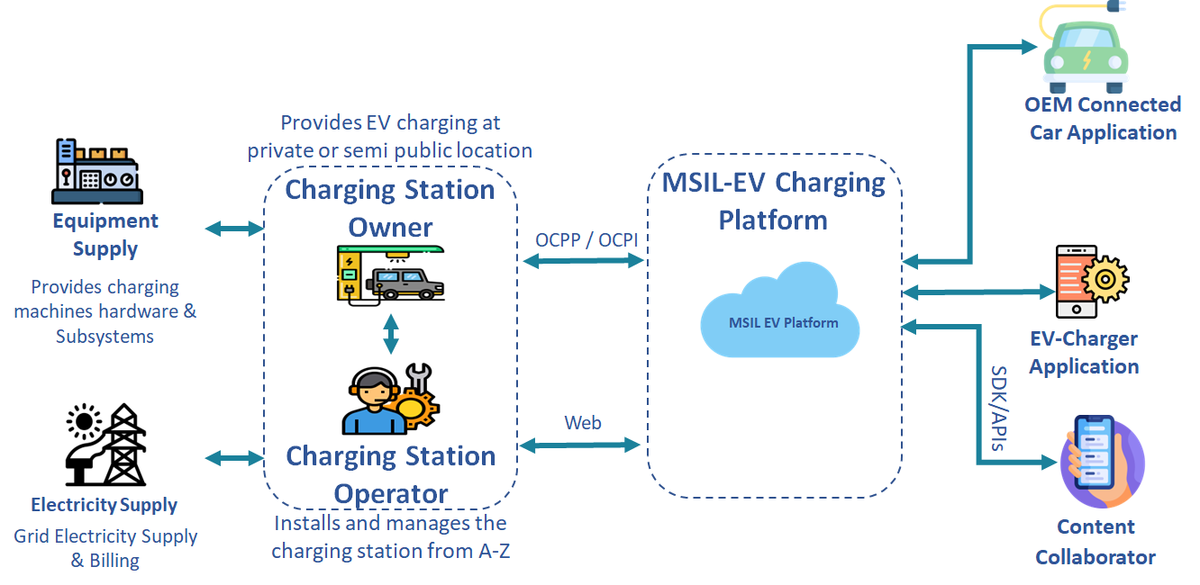

Figure 1: Key architectural blocks and system interaction with external systems.

Architecture Overview
The current and subsequent sections detail the architecture that would help realize an Electric Vehicle (EV) platform (or CSMS (Charging Station Management System) as per the terminology used in EV ecosystem). The proposed architecture should provide for all the functional/nonfunctional requirements as listed in references #•, •, •, • (primarily focused on MVP 0/1 scope as defined in the mentioned documentation). Realizing the solution as a "platform” brings inherent benefits like:

- Consumption of services via diverse set of client devices (mobile, desktop, etc.) as core functionality is exposed as set of APIs.

- Support additional/futuristic business models/use cases by development of corresponding applications/solutions on top of platform.

- Leverage “network effects” benefits as the volume and diversity of service consumers as well as service/data producers grow (Going forward, number of EV’s, charge stations are expected to grow exponentially)

- Benefits of reduced operational/maintenance costs by leveraging “economies of scale” and by optimizing the solution as per cloud consumption model (“Pay per use”) and related best practices.

In addition to foundational “platform centric” consideration, proposed solution would also adhere to the following architectural principles:

- Modular (self-contained and stateless) and interoperable “business logic” components ensuring unlimited horizontal scalability.

- “API first” and “microservices” based architecture for design, execution, and deployment time flexibility/robustness.

- Best fit component selection from “cloud native” services or custom components. Preference for serverless/cloud native components (compared to cloud agnostic components) for enhanced development velocity, optimized cost, simplified architecture, minimal infrastructure management overhead, seamless integration of components and effective support, etc.

- Using well-known/commonly used architectural/design patterns for shorter learning curve.

- Decouple “data ingestion” from “data processing” as well as “data processing” from “data consumption” via queues, buffers, etc.
- Logging of all system events/activities for post facto analysis of errors, security incidents and/or to initiate remedial measures.

- Alignment with open standards and protocols (primarily OCPI, OCPP, ISO 15118) to ensure compatibility with partner systems/ecosystems.

- Adherence to cloud provider’s recommendations/guidelines (e.g., adherence to AWS “Well Architected Framework”)

- Compliance with best practices with respect to development/deployment (e.g., Continuous Integration/Continuous Deployment (CI/CD) pipeline realization and related automation).

- Event driven architecture for minimal coupling between components, improved resiliency, error handling, absorb unpredictable load patterns, etc.

- Compliance with security best practices and guidelines like “Zero trust”, “Defense in depth”, “Principal of lease privilege”, “data encrypted at rest as well as in transit” at application as well as transport layer, etc.

The high-level functional blocks of the proposed architecture along with interaction with external systems is shown in the following figure:)
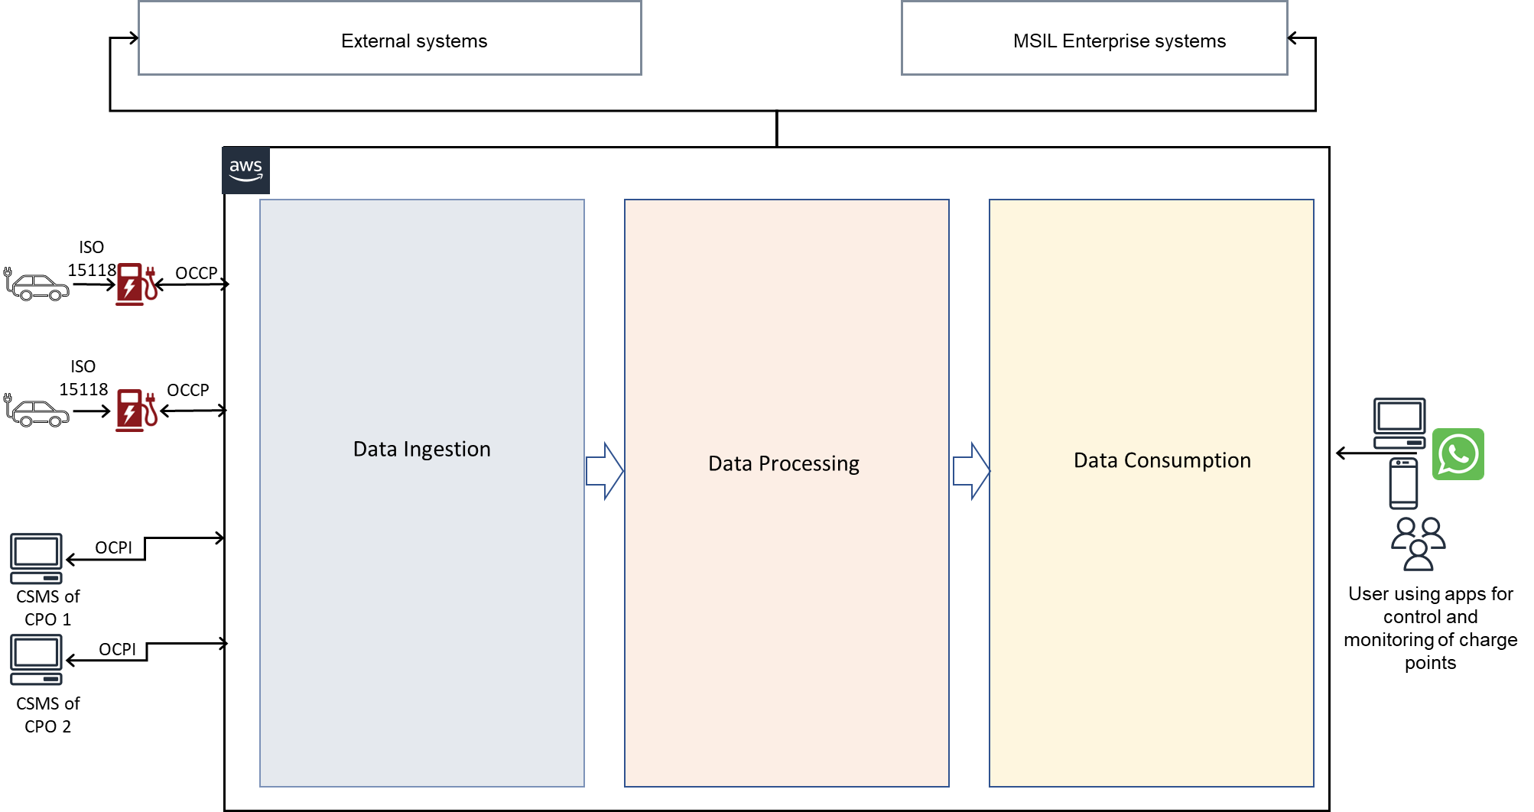

Figure 2: Key architectural blocks and system interaction with external systems.

Detailed Architecture

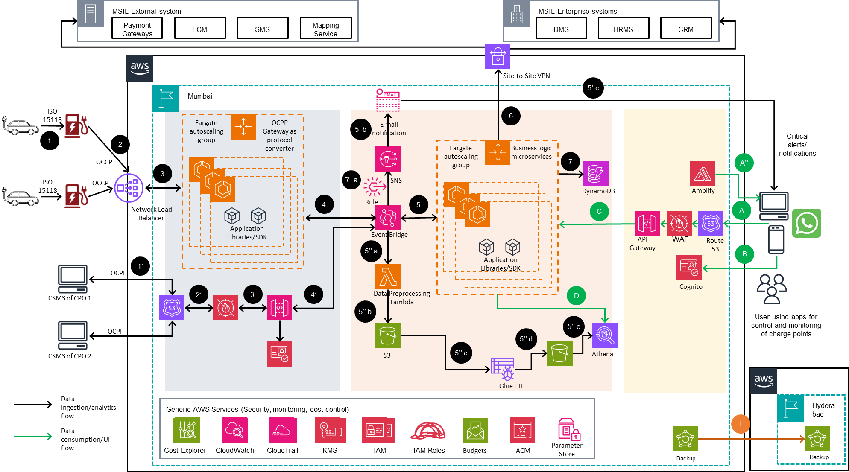

Figure 3: EV platform – Detailed Architecture
Before delving deeper into the architecture, it is important to note that “data ingestion” block show in prior figure is expected to perform two distinct roles:

- As a backend platform to EV charging station (like functionality of typical IoT platform where “charging stations” can be compared with field entities/devices) as per OCPP standard (indicated by the flow 1->2->3->4 in the prior figure).

- As eMSP to the CPO (platform to platform connectivity) as per OCPI standard (indicated by the flow 1’->2’->3’->4’ in the prior figure).

Above role definition would help to understand the main communication/data flows as is provided below:

OCCP Data ingestion flow (1->2->3->4):

- This indicates communication protocol that is followed between EV and the charger at the charging station. The current solution architecture is not directly involved in this communication flow and would primarily be CPO’s responsibility.

- This represents communication between the charging station and the envisaged EV platform as per OCCP standard. NLB (Network Load Balancer) would be exposing a publicly addressable endpoint that would be used by charge station’s communication module to make a connecting with NLB. NLB is chosen over ALB (Application Load Balancer) to support better performance/throughput and no specific need of application level (Layer 7) routing.

- NLB would forward the incoming requests to ECS (Elastic Container Service) to process the incoming requests. ECS with Fargate as “launch type” is chosen to align with completely “serverless” architecture principle. As mentioned in the diagram, ECS cluster would act as a kind of cloud gateway whereby it would be providing the functionality of “protocol translator” between OCCP and Rest protocols.
This conversion is required so that the data can be processed in a seamless manner by the downstream AWS services. This also allows for future extensibility (e.g., alignment with IoT AWS pattern with data ingestion done by IoT core, streaming analytics using IoT analytics, etc.). Fargate nodes would dynamically “scale out/in” based on incoming load as reported by NLB. As the OCCP communication is bidirectional in nature, NLB would forward the connection requests to the Fargate instances to open WebSockets with the charging station’s communication modules.

- Fargate cluster would translate the incoming OCCP requests/commands into corresponding events that would be processed by downstream components. These events would be sent to EventBridge for further processing and routing. The events generated by gateway would include all the related information about the OCCP command/request source (like station id, timestamp, etc.).

OCPI Data ingestion flow (1’->2’->3’->4’) – Essentially data exchanged between CSMS of another CPO over OCPI protocol:

- This bidirectional data exchange would require a “named endpoint” that would be provided by Route 53 service.

- Incoming requests would be subjected to WAF (Web Application Firewall) rules that would provide an additional layer of security against malicious actors. This is in alignment with “Defense in depth” and “Zero trust” security principles. Primarily, the rules configured using WAF rules would correspond to “whitelisting” of partners I.P. addresses.

- WAF filtered traffic would flow to API Gateway that is configured to operate as “Web Socket” to allow for bidirectional OCPI communication. API Gateway would also allow for other generic functionalities like traffic throttling, metering, API versioning, etc. API Gateway would integrate with Cognito to provide authentication tokens (e.g., OAuth2 tokens) to allow for API authentication.

- API gateway inherently supports the integration with EventBridge and that would be used for converting the OCPI API calls to “system events” that would be processed by downstream components. Although currently there is no use case that requires the consolidation of both OCPP and OCPI events in EventBridge, there is a possibility that this flexibility might be leveraged in future.

Data Processing flows (5->6->7, 5’a->5’b->5’c, 5’’a->5’’b->5’’c->5’’d->5’’e):

- EventBridge would route the relevant events to another Fargate cluster which hosts the core “business logic” functionality. The usage of two Fargate clusters aligns with the requirement of decoupling between data generation and data processing.
“Business logic” cluster would be implemented in the form of microservices and would act as a “backend” for both OCCP and OCPI protocols. (Although an implementation/design decision, microservice in this cluster can correspond to different modules of OCPI/OCPP (e.g., Versioning, Locations, CDR’s, etc. in case of OCPI).
Inter microservice communication would also be done by events orchestrated through EventBridge. Depending upon the rules configured in EventBridge and the incoming events, appropriate Fargate task would be invoked from Fargate cluster. Although in the diagram, Fargate cluster is shown as the target, however it is possible that for certain functionalities (especially short running tasks), EventBridge may invoke Lambda instead of Fargate task (not shown in the figure for clarity’s sake).
As indicated in the figure, reverse communication flow (where business logic microservices would be generating OCPP/OCPI events after processing incoming data/commands) would again be sending appropriate events to EventBridge.

- Fargate hosted microservices would be communicating with on-premises systems (enterprise or other external systems) via site-to-site VPN service. As communication modalities will be different for different external/enterprise system, there is a possibilty that some of the systems might not require VPN connectivity and open network with SSL might suffice the connectivity requirement.

- This indicates that DynamoDB would be used by business logic microservices/Fargate tasks for persistence store. There is a possibility that while designing individual microservices a need for more suitable and purpose-built databases may arise (e.g., Graph database/Neptune may be suitable for storing relationships between entities/personas).
Mention of DynamoDB here is no way indicating any binding/restriction on choice of more appropriate databases. The intent of mentioning DynamoDB is that it should be the “default database” choice in case there is no other suitable database and in fact, exercise of identifying “right fit” database needs to be repeated for each microservice separately in alignment with the desired polyglot nature of these microservices.

Real time notification flow:(5’a->5’b->5’c):

- This option is for taking immediate action on the events that are being generated by the system (akin to “streaming analytics”). This would be accomplished by defining corresponding rules (“In case of connectivity loss to a particular charge station, send email/SMS to the registered users”, for example) in the EventBridge that would use SNS for sending notifications to interested parties/personas. Although only e-mail is shown as a notification mechanism, the system would support notifications using SMS, push notifications would also be provided.

- This indicates sending the notifications via AWS service i.e., SES (Simple E-mail Service). As mentioned in the previous point, depending upon the notification mechanism (Twilio or Firebase Push Notification in case of SMS) would be used.

- This indicates the desired notification (email, SMS) being delivered to the preferred system/persona.

Analytics flow(5’’a->5’’b->5’’c->5’’d->5’’e):

- EventBridge will route analytics related events (along with associated data) to a pre-processing Lambda. This lambda would do the required data filtering, de-duplication, data transformation, etc on the raw data received from EventBridge. The exact functionality of this Lambda would be determined by the type of analytics workload/use case.

- The transformed data would be saved in S3 to have a copy of the data before performing any ETL (Extract Transform Load) function on the incoming data. This construct also corresponds to “data lake” pattern where raw data (along with its subsequent transformations) is stored in object storage (S3)
- Arrival of the data on S3 would trigger an event that would initiate ETL workflow by AWS Glue. The workflow would involve operations like data cataloging, data transformation in columnar format, etc. The exact nature of these transformation would again depend on the type of analytics required. Essentially, the transformation would enable the data to be processed by warehouse engines like Amazon Athena.

- This is the intermediate data that is persisted for future troubleshooting/debugging purposes or for trying different analytics training options/algorithms.

- This indicates data consumption by Athena (serverless, interactive analytics service). As data is being consumed from object storages (S3). The components of Athena that would be used and the analytics applications that are built on top of Athena would depend on the type of analytics use case that needs to be supported.

Data Consumption flow (A->B->C->D):

- The client devices (mobile, web interfaces) connect with defined endpoint using Route 53 service.

- Cognito service is used to provide authentication functionality (identity, access, refresh tokens, etc.) to the calling clients.

- API requests after getting filtered for security (by WAF) would be transferred to API Gateway which in turn invokes the required Fargate task to provide the data/information required to fulfill API needs. As was mentioned in the earlier section, in case the request can be fulfilled by a short running task (fetch a data point from DynamoDB, for example), the same can be implemented using Lambda as well.

- This refers to the scenario where data required by the client (specific analytics/predicted value) is not available within Fargate cluster and needs to be pulled from Athena.

App Development/deployment Flow (A’’):

- Amplify is used to develop and host application’s backend and frontend (both web and mobile applications). It does provide lot of features “out of the box” (like integration with source code repository, authentication logic, inbuilt data store, etc.).
However, it also includes some amount of learning effort. The extend to which this service would be leveraged would depend on number of factors like application developer’s comfort with the service, amount of effort reduction compared with application developed using native tools/technologies, etc.

Disaster Recovery Flow (I):

- The disaster recovery mechanism that is depicted is “Backup and Restore” as it provides the required balance between cost and availability requirements. Alternate disaster recovery mechanisms namely pilot light, warm standby, active/active would provide for lower RTO (Recovery Time objective) but it would also require parallel infrastructure to be provisioned in the alternate region incurring additional costs.
In the “Backup and Restore”, data (infrastructure provisioning scripts, persistent data from S3/DynamoDB, etc.) from the primary region would be continuously replicated in the back up region. The cost involved in “backup and restore” involves primarily inter region data transfer and cost involved in storing data in object storage.
Although, the primary region has inbuilt availability (usage of serverless/managed services provide full intra region resiliency), the disaster recovery mechanism mentioned here would be invoked in case the complete region faces outage – a highly unlikely event.

In addition to the preceding flows, there would be a requirement of additional generic/miscellaneous AWS services (listed as Generic AWS Services in the figure). These services are explained as follows:

- Cost Explorer: The service helps to understand the cost and resource utilization in real time using dashboards, filters, etc. The service will come in handy to determine the services that are major contributors to the monthly bill and trigger actions for cost optimization. Additionally, the service helps to predict the expected monthly bill considering the current/historic usage trends.

- Cloud Watch: Cloud watch would be used for application as well as infrastructure monitoring (real time metrics, logs, event data) and aid in troubleshooting/debugging purposes. Helps to collect performance metrics such as CPU, memory, network, and disk information as well as performance events and automatically generates custom metrics used for monitoring and alarm.

- Cloud Trail: This service provides logging functionality and helps to track application and user activity.

- KMS (Key Management Service): KMS provides symmetric as well as asymmetric keys as per application requirements. It stores the generated keys in hardware security modules (HSM) to protect the integrity of keys.

- IAM: The service is used to provision users in AWS account as well as grant them permission for specific resources.

- IAM roles: An IAM role is like an IAM user, in that it is an AWS identity with permission policies that determine what the identity can and cannot do in AWS. However, instead of being uniquely associated with one person, a role is intended to be assumable by anyone who needs it (Refer AWS documentation for more details).

- Budgets: This would be used to set monthly budgets on the AWS account to control costs. In case the cost goes beyond the defined threshold, alerts/alarms would be sent to the configured entities.

- ACM (Amazon Certificate Manager): This service would be used to provision SSL certificates that would be required to enable transport layer security (to provide secure API’s over HTTPS channel). In our context, the generated ACM’s would be used by services like API gateway.

- Parameter store: The service would be used for providing secure, hierarchical storage for managing application configuration data. This would help in changing the application behavior at run time without the need for code build, deployment, etc.

- AWS Backup: Provides ability to replicate data across regions while monitoring the data backup/restore activity using Cloudwatch as was mentioned in the data back flow.

Key Architectural Decisions

# | Topic | Options | Selected Options | Justification | Status
1 | Selection of disaster recovery approach + infrastructure deployment in alternate region | Standard disaster recovery options include:  - Backup and restore.  - Pilot light  - Warm standby  - Multi-site, active/active | #1 | The assumed RPO and RTO requirements (5 mins and 30 minutes respectively) can be met with “backup and restore” option without incurring any additional cost for maintaining redundant infrastructure in the backup region. The charges incurred would be only inter-region data transfer charges (included as part of AWS Backup pricing).  Region wise outage is a rarest of rare occurrence and the proposed architecture provides sufficient intra region high availability by usage of serverless services. | Closed
2 | Selection of serverless components for developing/hosting web/UI application | - Web/UI application can be developed/hosted using serverless service (Amplify, Cognito, Lambda, API Gateway)  - Web/UI application can be developed/hosted using IaaS/PaaS services (VPC, internet gateway, EC2 webservers, etc.) | #1 | - Serverless architecture has advantages from cost, complexity, and overall management standpoint. These factors tend to reduce the UI development/deployment timelines drastically, which is one of the key business objectives.  - Serverless components can result in vendor (AWS) lock-in, however, main UI logic is expected to be written in node.js that is easily portable across cloud platforms, this won’t result in a major disadvantage. Other infrastructure component like API gateway, Cognito can easily be migrated to other vendor’s services | Closed
3 | Data store for data/analytics pipeline | - DynamoDB  - S3 | #2 | - The volume of data processed would be huge and using DynamoDB would result in higher monthly bills.  - S3 allows for future extensibility for a scenario where solution is to support “data lake” requirements (storage of unstructured data from charge stations for analysis, etc.). | Closed
4 | AWS Amplify for frontend/backend development | - Usage of Amplify Studio for design and development of mobile/web applications.  - Usage of native tools for development of mobile/web applications | Option#2 for MVP1 | - Development team comfort level in the traditional tools and steep learning curve. | Closed (Decision to be reevaluated at MVP2/3 stage)
5 | Tool chain for CI/CD pipeline. | - Usage of open-source tools (e.g., Jenkins for build automation, GitHub for code repository, sonarqube for static code analysis, etc.)  - Usage of AWS native tools/services (e.g., CodeCommit for code repository, CodeBuild for build automation, etc.) | Option#1 | - Although the AWS native tools tightly integrate with AWS Code pipeline service and would be a better option, however as MSIL San is already using open-source tools in other projects, decision is to integrate mentioned open-source tools in CI/CD pipeline. | Closed

Deployment (CI/CD) View (*)
Mapping of AWS services to Azure equivalents is listed below:

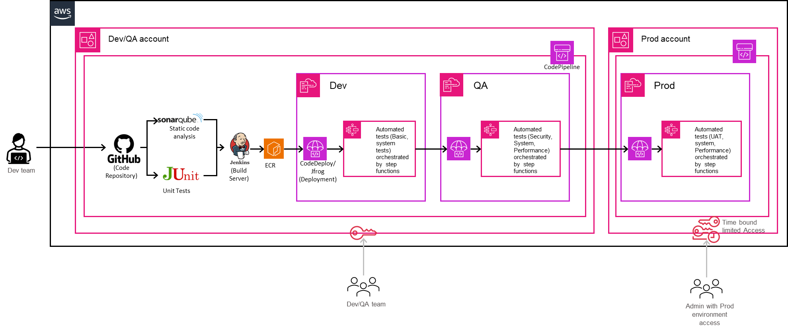
Figure 4: Deployment (Continuous Integration/Continuous Deployment) View

* Reference: https://docs.aws.amazon.com/codepipeline/latest/userguide/tutorials-four-stage-pipeline.html

Architectural considerations for NFR’s
Most of the NFR’s listed in the RFP can be effectively complied with by adhering to AWS’s recommended “Well Architected Framework”. Specifically, NFR’s mentioned in RFP document and its reflection in architecture is detailed in the following table:

NFR | Architectural Consideration
Availability | - Selection of serverless services ensure full intra region availability. In the highly unlikely event of whole region facing outage, a basic disaster recovery solution is provisioned (“Backup and Restore”). Although “Backup and Restore” provide RTO in the range of 0.5 to 1 hours, however it does provide a cost benefit as parallel infrastructure is not to be provisioned in alternate region.  - Database/storage services provide inherent availability (although related configuration would be required), similarly usage of ECS Fargate cluster ensures that node replenishment is handled in an automated fashion by the framework.  - From an application standpoint, the regular heartbeat received from field devices will indicate the connection health and same would be reflected in the application dashboard.  - One component that would deviate from serverless implementation is EC2 server for hosting open-source CI/CD tools. This component however doesn’t impact production/application workloads and would primarily impact development/deployment of application patch/enhancements. This potential risk can be mitigated by ensuring regular backup of EC2 disk on S3 bucket.
Reliability | - Leveraging cloud’s inherent elasticity to handle traffic variations.  - Continuous data backup (intra region as well as inter region) ensures that the system can resume from a failed state with minimal lag/downtime.  - Verification/validation activities to test failure scenarios and automated recovery.  - Making provision for additional/backup VPN connectivity with enterprise/on-premises systems (for production workloads)  - As stated in the architectural principles, deployment of the core logic using microservices aligned to event driven architecture would ensure a loosely coupled architecture further enhancing the reliability posture.  - Usage of EventBridge would act as temporary event store in case consumers aren’t able to handle the load or are facing outage.  - Leveraging parameter store as a central component for managing application configuration would help from reliability standpoint as configurations can be changed/restored with minimal effort/time.  - Externalizing the state of the microservices (usage of DynamoDB as data store).  - Usage of WAF on both data ingestion and data consumption paths ensure effective containment of unwarranted traffic.
Scalability | Cloud native/serverless solutions are inherently scalable, additional considerations include selection of serverless/managed services for core functionality.
Performance | - Selection of serverless/managed services for core functionality.  - Usage of websockets at the transport layer ensures that overhead of connection establishment/disconnection is minimal.  - Automated monitoring the solution by effective observability techniques (cloudwatch metrics, logs) ensures that performance degradations are addressed in a timely manner.  - Usage of NoSQL database (DynamoDB) as default database choice ensuring higher throughput.  - Keeping an eye on the latest services launched by cloud provider (AWS) and regular review of the architecture to incorporate performance improvement opportunities.  - Flexibility to use “purpose built” database for each microservice rather than “one size fits all” approach.  - Including automated performance/load tests as part of CI/CD pipeline.  - Usage of appropriately sized cloud components (e.g., VPN) to minimize chances of resource overutilization or underutilization.  - NLB (instead of ALB) for load balancing would also provide for encryption offloading (SSL termination).  - Relying on IaC (Infrastructure as Code) for automated infrastructure provisioning provides deployment time efficiency.
Security | - Data encrypted at transport layer (SSL usage).  - Alignment with partner’s security implementation (OCCP and OCPI being application-level protocols doesn’t provide strict security compliance requirements and it would be left to partner’s discretion (e.g., CPO’s) to define security level (basic authentication vis-à-vis mutual authentication by using X.509 certificates for both client and server)). The envisaged solution needs to support all the possible security mechanisms expected by partner solutions with a bias towards higher security posture/mechanism.  - Usage of WAF at both data ingestion and data consumption flows.  - Logging of all events for traceability purposes as well adherence to principle of “least privilege access” (production workloads would have a separate account as mentioned in the CI/CD section, for example)  - Usage for temporary access tokens for external systems/personas on both data ingestion as well as data consumption side. Usage of timebound certificates for similar reasons.  - Usage of KMS for storage of application keys as well as ensuring that data is encrypted both in transit as well as in motion (VPN, SSL usage).
Usability | - Ensuring optimum system/technical/API documentation  - Strict adherence to design guidelines of MSIL San.
Extensibility | - Usage of microservices as well as event driven architecture ensures modularity with resulting extensibility.  - Loose coupling between components ensures quick/easy replacement of components.
Disaster Recovery | - “Backup and restore” disaster recovery technique to ensure regular data backup between Mumbai and Hyderabad regions. Although not the ideal approach from RTO considerations but gives a cost effective “disaster recovery” implementation.

RFP Requirements/Architecture traceability
RFP Requirement | Covered in current document section#
Sec#8 (Business requirement) | - Sec#3 (Especially the verbiage around Amplify, data consumption section)  - Sec#3 (Architecture alignment with OCPP and OCPI protocols, other protocols OSCP, ISO15118, open ADR are not directly relevant to the current architecture scope.)  - Sec#3 also covers additional requirements of customer support, Payment management and collections system, Data and analytics support, Integration with existing MSIL ecosystem applications like CRM, DMS, HRMS and other allied platforms.
Sec#8 (Non-Functional Requirements) | - Sec#6

References
- RFP-EV Charging Platform.pdf (dated 23-March-2023)
- RFP addendum
- EV Platform SOW Final Draft.pdf (dated 19-July 2023)
- EV_Charging_User_Story_Document 05th Sep.xlsx
- https://evroaming.org/app/uploads/2021/11/OCPI-2.2.1.pdf
- https://www.openchargealliance.org/protocols/ocpp-201/
- https://www.iso.org/standard/77845.html
- https://docs.aws.amazon.com/whitepapers/latest/disaster-recovery-workloads-on-aws/disaster-recovery-options-in-the-cloud.html, https://aws.amazon.com/blogs/architecture/disaster-recovery-dr-architecture-on-aws-part-i-strategies-for-recovery-in-the-cloud/

Annexure A: OCPP/OCPI nonalignment

There are certain functionalities where there is misalignment between OCPP and OCPI protocols especially w.r.t. reservations and same is listed below:
- OCPI allows to just specify a Location ID with the CPO ensuring that at least one EVSE is available. This requires logic on the CPO back-office software as OCPP handles only individual Charge stations.
- OCPP requires a specific charging station to be reserved, but there is no official way to communicate this via OCPI
- Neither system can properly handle future reservations or queue reservations
- No official way for CPOs to communicate max advance reservation time (this means in principle a CS could be reserved between 'now' and 5 months from now)
- OCPI 2.1.1 doesn’t support cancellations.
- OCPP supports three tier charge point model (OCPP 2.0 supports a 3-tier model: Highest level is a Charge Point, A Charge Point can have one or more EVSEs, Every EVSE can have one or more Connectors.) whereas OCPI does not have this model. In OCPI, Location is at the highest level. Each location can have multiple EVSE and every EVSE can have one or more Connectors. When mapping from OCPP Charge Points to OCPI, there are 2 options:
  - One Location for a group of Charge Points at the same location. (preferred)
  - One Location per Charge Point at the same location.

Annexure B: Integration Architecture with External System
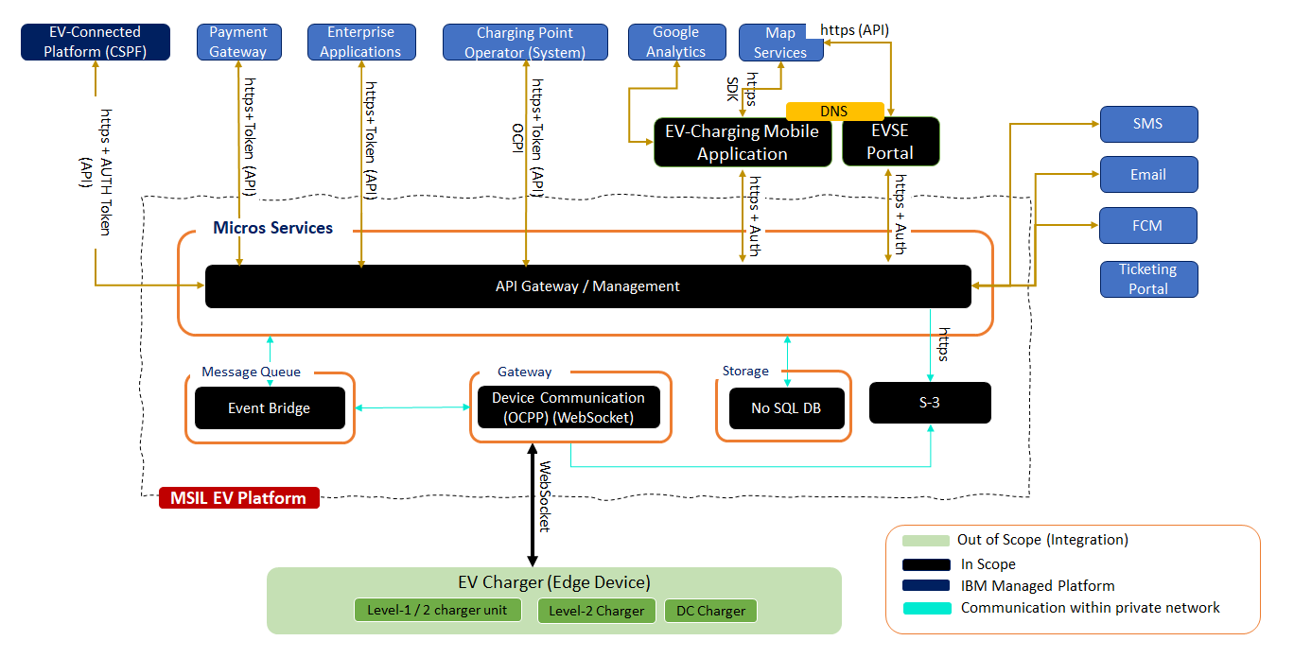
Figure 5: Integration Architecture with External System

Annexure C: Master and Transaction Data Components
# | Module Name | Type of Data | Description
1 | Customer Management | Master Data | Store / Process customer related information
2 | Charger Management | Master Data | Store / Process charger related information
3 | User Management | Master Data | Store / process the users of the web portal
4 | Charger Configuration Management | Master Data /Transactional Data | Store configuration details of charger and manage the history of the configuration
5 | Dynamic Pricing | Default Master Data / Transactional Data | Store the default value and store the transaction data relate to pricing
6 | Alert & Notification | Transactional Data | Store and process all the critical alert generated by the system and notification to customers.
7 | Monitoring and Dashboard | Transactional Data | Charger status, critical process monitoring alerts.
8 | Service & Operation | Transactional Data | Maintenance of the chargers,
9 | Payment Services | Transactional Data | Manage all payment related processing
10 | Broker Consumer | Transactional | Program to consume the topic of Kafka and produce the data into Kafka services
11 | Monitor & Logging | Transactional
12 | Partner Management | Master Data / Transactional | Manage the partners on-boarded on MSIL-EV platform.
13 | Authentication Service | Transactional | Authentication of the external system / applications
14 | Master Data | Master Data | This is common master data, which will be used by platform for example, State, dealers, drop down values in application.

Annexure D: System Context

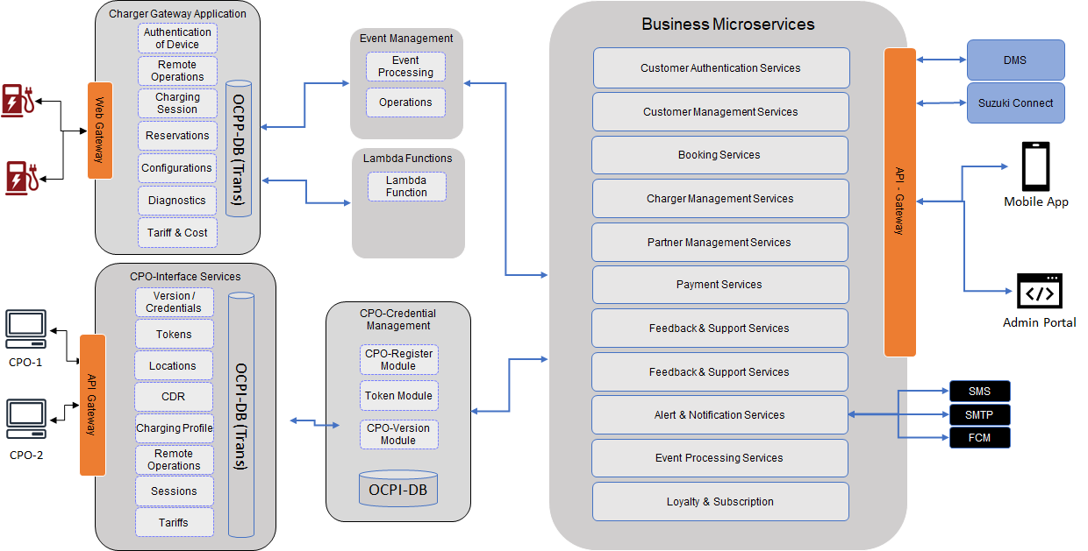
Figure 6: System Context Diagram

Annexure E: Component View

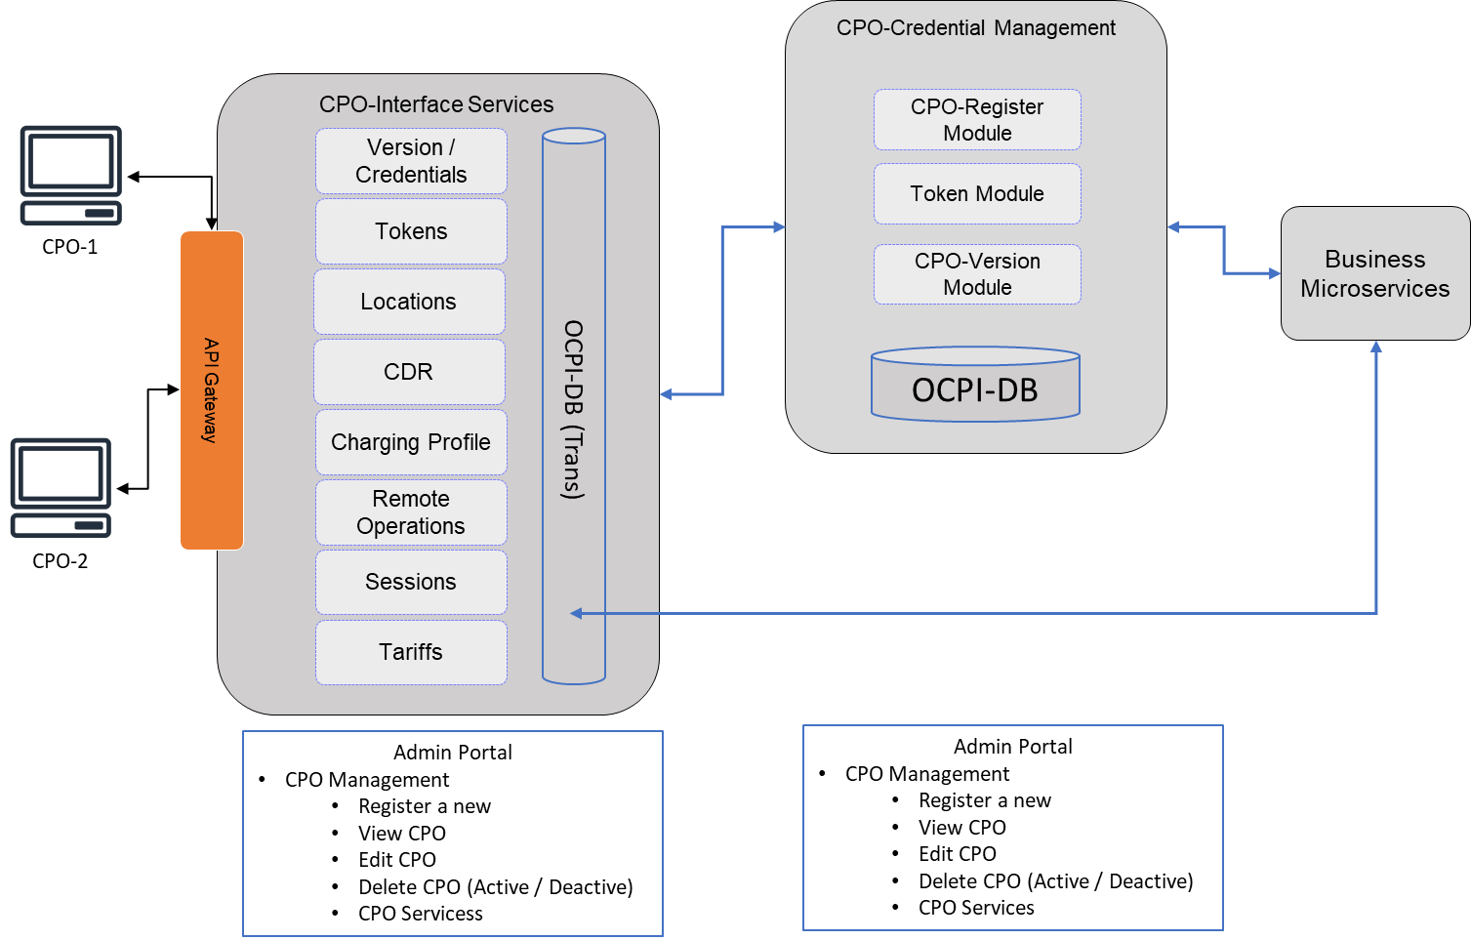
Figure 7: Component View of Each Microservice – (OCPI-Interface Services)

Annexure F: AWS BOM (Bill of Material) + Calculator Link

